**Name:** Siddhant M Mangale   
**Class:** B.Tech **Div:** A  
**Roll No:** 31

**Experiment No. 2**

Aim: To implement Basics of Julia for Data Analysis with Strings Basics of Julia for Data Analysis – Loops , conditionals, Functions in Julia.

1. Write a Julia program to demonstrate How to get a string

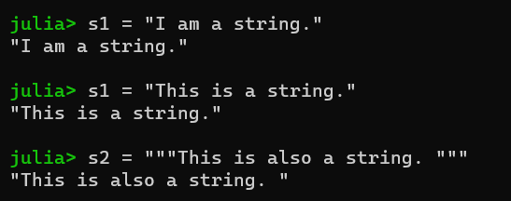

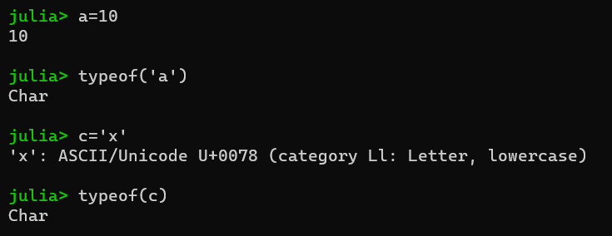

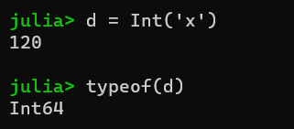

1. Write a Julia program to demonstrate String interpolation

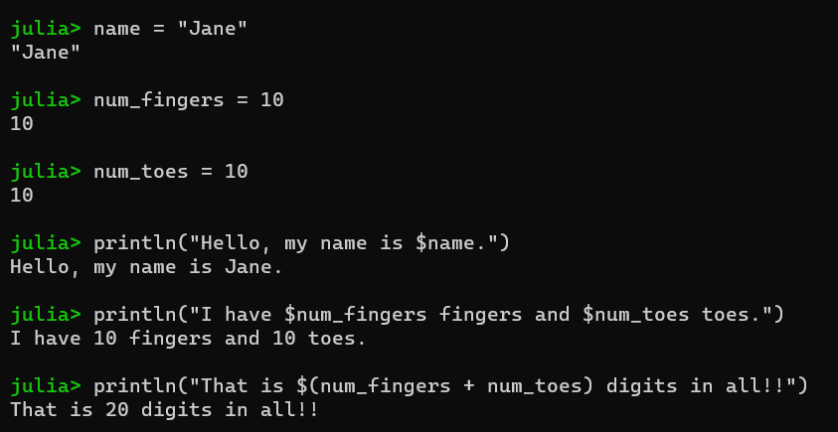

1. Write a Julia program to demonstrate String concatenation

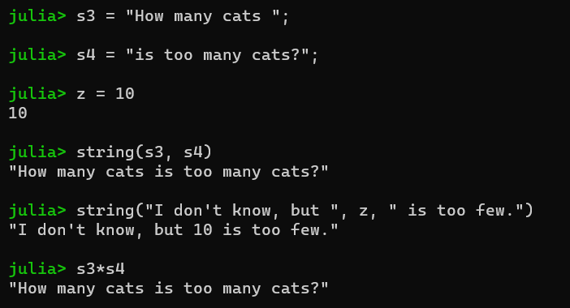

1. Implement Julia Program to display 1 to 10 numbers

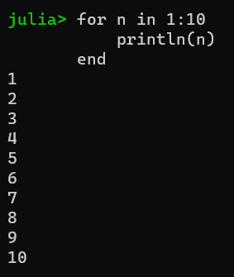

1. Implement Julia Program to display even and odd from 1 to 10 numbers.  
   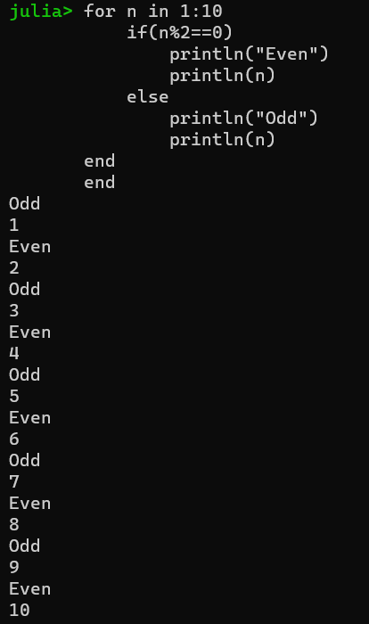
2. Implement Julia Program to display which is the greater,smaller and equal number from entered 3 numbers using function.  
   